Steps in Loading a Table:

NOTE: in hive-site.xml, the following is configured in cloudxlab,

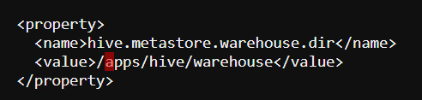

Upload file:



Create Database and Create Managed Tables within the Database:

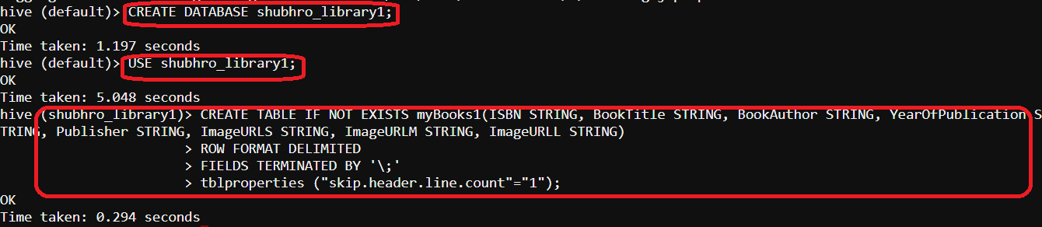

LOAD Data into table created (as per understanding, the file used to load i.e. attachment_Dataset_Books.xls should be deleted from the location and a table will be created in shubhro_library1 with the data)

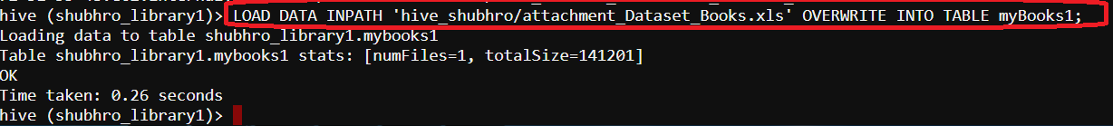

Hue Snapshots:

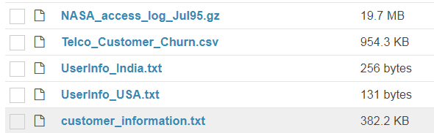

attachment_Dataset_Books.xls is missing now

Hue snapshots in /apps/hive/warehouse

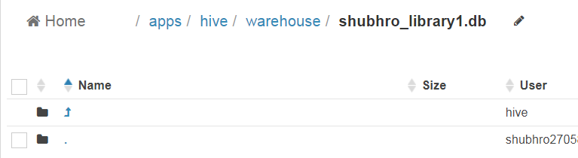

i.e Table myBooks1 not present here

Although table has been formed and data loaded

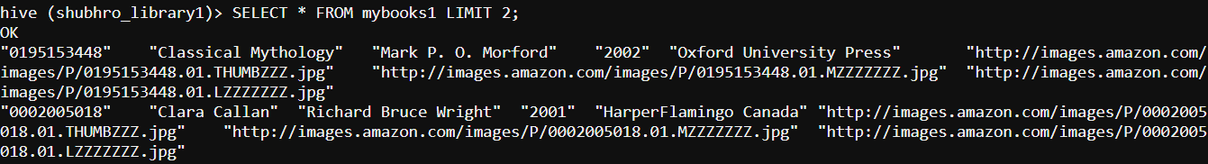

STEP-2

Create an External Table:

I followed the steps to upload the dataset again and create an external table.



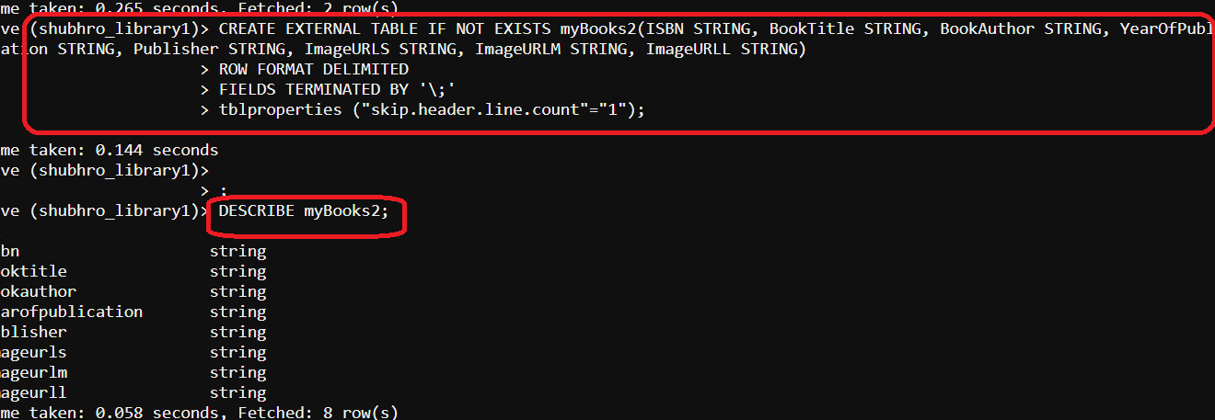

Load data into external table:



Hue Snapshots,

Same as in previous case

Hive DB snapshot:

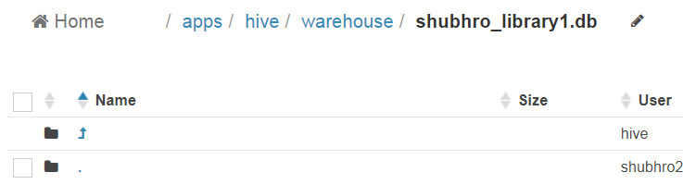

But the data is loaded and the table is created properly.